API Integration

|  |  |
| --- | --- |
| Date | 12-11-2022 |
| Team ID | PNT2022TMID34159 |
| Project | Predictiong th energy output of wind turbine based on weather condition |

Feature code(API Key): “f2f445570a7958fd890ce89459bac7fa”

Link for API Call:” <https://api.openweathermap.org/data/2.5/weather?q=London&appid=f2f445570a7958fd890ce89459bac7fa>”

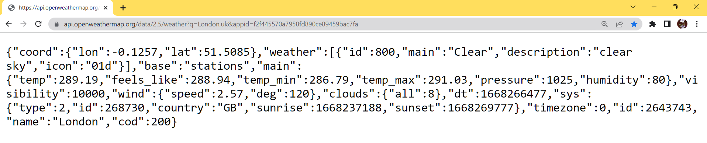

--------------------------------------------------------------------------------------------------------------------

Feature code(API Key): “c875ff704d604f8e80a5a658c60e3f59”

Link for API Call:” <https://api.openweathermap.org/data/2.5/weather?lat=76&lon=45&appid=c875ff704d604f8e80a5a658c60e3f59>”

